How To: Complete a Psychotherapy Treatment Plan
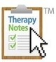
Jakki
May 10, 2018 09:24
Follow
The Diagnosis, Objectives, and Frequency of Treatment are initially recorded on a client's Psychotherapy Treatment Plan and pull forward into subsequent Psychotherapy Progress Notes for the client. Because of this, a Treatment Plan must be completed prior to completing a Progress Note for a client's first scheduled Therapy Session.
If you do not want to write a Treatment Plan before the first appointment with a client, you can schedule a Consultation or Psychotherapy Intake and subsequently write either a Consultation or Psychotherapy Intake Note. Note: An Intake is not needed if you complete a Treatment Plan.
TherapyNotes will prompt you to create a Treatment Plan after you create an Intake Note for a client and will generate a To-Do list item as a reminder to create a Treatment Plan for the client. To learn more about creating notes and note writing tools in TherapyNotes, read How To: Create a Note.
Role Required: Clinician, Intern, or Clinical Administrator

Note Header
The note header automatically fills in information for the clinician, client, and date and time the note was created. To edit information in the note header such as the Note Title or Date & Time, click anywhere on the note header or click Edit in the upper right corner.

Diagnosis
The Diagnosis fields feature searchable DSM-5 diagnoses, allowing you to easily add and edit diagnoses. If an Intake Note was completed prior to the creation of the Treatment Plan, the DSM-5 diagnoses, descriptions, and justification will automatically pull forward into the Treatment Plan. Diagnostic information will also pull forward into subsequent Psychotherapy Progress Notes and Psychological Evaluations.

Presenting Problem
If an Intake Note was completed prior to the creation of the Treatment Plan, the Presenting Problem will automatically pull forward into the Treatment Plan. Otherwise, enter the reason for treatment.

Treatment Goals
Enter the broad goals for the client's treatment and the estimated time for the completion of treatment.

Objectives
Enter each of the steps you intend to take to work towards the Treatment Goals.
Multiple objectives may be entered by clicking Add New Objective. For each Objective, enter the Treatment Strategy / Interventions and the estimated time for the completion of the objective. Each Objective is pulled forward into subsequent Psychotherapy Progress Notes for the client so that progress can be regularly documented.

Frequency of Treatment
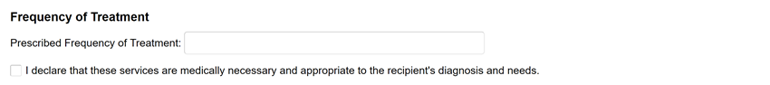
Enter how often you plan to see the client moving forward in the Prescribed Frequency of Treatment field. This information is pulled forward into subsequent Psychotherapy Progress Notes for the client.
Before signing the Treatment Plan, select I declare that these services are medically necessary and appropriate to the recipient's diagnosis and needs to continue with treatment.

Sign and Save
Note: In order to save a Psychotherapy Treatment Plan, you must enter the Diagnosis, Presenting Problem, and Prescribed Frequency of Treatment. All other fields are optional.
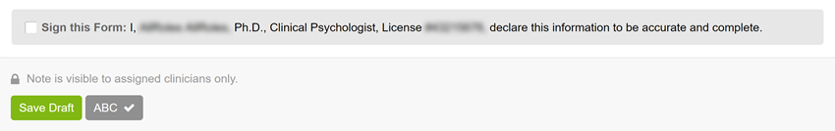
Once you have completed the Psychotherapy Treatment Plan for your client, select the Sign this Form checkbox to electronically sign the note and click the Create Note button.
To save an unfinished Treatment Plan, leave Sign this Form unchecked and click the Save Draft button. You may access your draft later from your To-Do list or click Patients > Patient Name > Documents tab.

